REQUEST FOR PROPOSALS

Entrepreneurship Training Services
in the Park Heights Master Plan Area

Issued: November 20, 2023
Due: January 12, 2024

Bidders Conference: December 14, 2023
Register: https://www.eventbrite.com/e/entrepreneurship-training-services-bidders-conference-for-rfp-tickets-763542826147?aff=oddtdtcreator

MacKenzie Garvin
Director
Mayor’s Office of Employment Development
Brandon M. Scott
Mayor
City of Baltimore

REQUEST FOR PROPOSALS
Entrepreneurship Training Services
in the Park Heights Master Plan Area

TABLE OF CONTENTS

I. PURPOSE/BACKGROUND

II. QUALIFICATIONS AND RESPONSIBILITIES
III. TECHNICAL PROPOSAL FORMAT
IV. FUNDING/BUDGET GUIDELINES
V. BUDGET FORMAT

VI. EVALUATION CRITERIA
VII. EMPLOY BALTIMORE HIRING INFORMATION

SECTION I
REQUEST FOR PROPOSALS
Entrepreneurship Training Services
in the Park Heights Master Plan Area

PURPOSE/BACKGROUND

PURPOSE OF FUNDS

The Baltimore City Mayor’s Office of Employment Development (MOED), on behalf of the Mayor and City Council, requests proposals for entrepreneurship training services concentrated in the Park Heights Master Plan Area designated by the Pimlico Community Development Authority. The contracted organization will provide education, consultation, and support to Park Heights residents with entrepreneurial interests or plans to start a small business. This project will expand opportunities for historically marginalized people, bolster the economy through the creation of small business, and provide a pathway to employment for Park Heights residents who face barriers to workforce entry. This Request for Proposals seeks vendors to conduct entrepreneurship training, following or based on a nationally recognized curriculum, to prepare Park Heights residents to plan, pitch, build, and grow their small business enterprises. Additionally, the chosen vendor(s) will conduct a pitch competition for participants and award subsidies for entrepreneurial start-up costs to the chosen winners.

BACKGROUND

The Mayor’s Office of Employment Development (MOED) is Baltimore’s workforce development agency and American Job Center operator. MOED serves as the City’s primary agent of workforce development services for employers, career seekers, people with disabilities, career changers, returning citizens, laid-off workers, and youth. More information on MOED is available at https://moed.baltimorecity.gov.

MOED’s mission is to deliver economic justice to Baltimore residents. To MOED, economic justice means creating an equitable workforce system that responds to all residents’ needs and provides viable economic opportunities to all residents especially those who have been generally and systemically disadvantaged. We believe that every resident deserves the right for meaningful work and a hopeful future.

MOED has received funding for economic and career development projects in the Park Heights Master Plan Area, including to support entrepreneurs and small business start-ups. In partnership with the selected contractor, MOED will work with the Baltimore Development Corporation and the City’s Small Business Resource Center to connect residents interested in entrepreneurship and innovation to training resources to assist them in preparing a business plan, applying for loans, obtaining credit, understanding business taxes, and gaining other essential knowledge. The project will also award grants of at least $2,500 for start-up costs to selected participants through a pitch competition.

CONTRACT PERIOD AND AMOUNT

The selected vendor(s) will have up to 13 months commencing no later than May 15, 2024 and expiring no later than June 30, 2025 to enroll and train at least 40 participants and to award subsidies for business start-up costs to trainees selected as part of a pitch competition. The contract amount may not exceed $76,000.

SCOPE OF WORK

The proposal shall include a stated commitment to complete the following tasks and deliver the following services/products:

- Recruit, screen and enroll aspiring entrepreneurs residing in the Park Heights Master Plan area designated by the Pimlico Community Development Authority. The proposal should identify community groups and associations the applicant will partner with to ensure eligible residents are connected to this training opportunity.

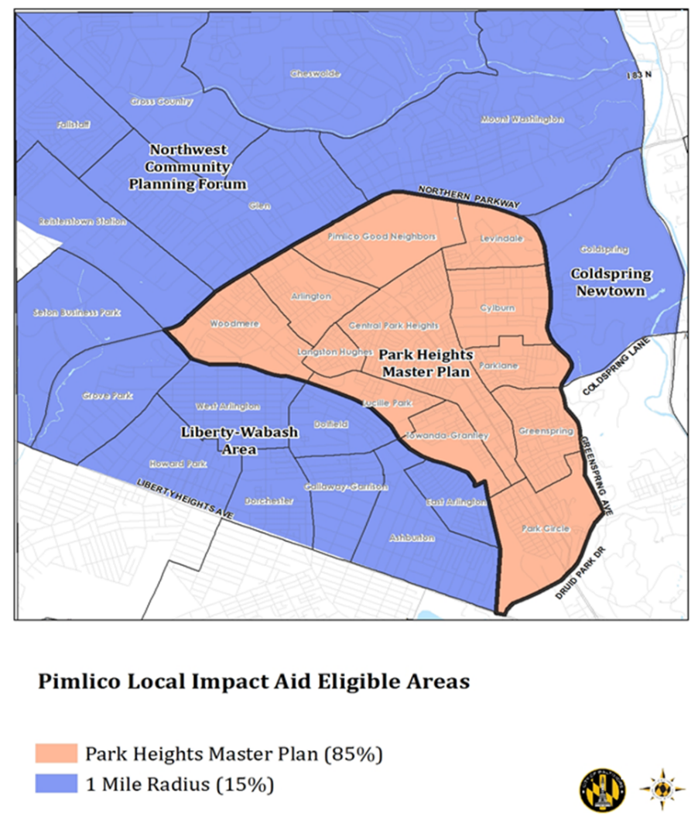

- Deliver entrepreneurial training to include:

  - Practices that are consistent with a race equity and inclusion framework
  - A curriculum following a nationally recognized model or based on nationally recognized standards of entrepreneurship education
  - Opportunities to engage in mentorship experiences with local businesses or executive leadership
  - Case management services, including use of the Unite Us tool to make referrals to partner organizations for barrier removal and other supports
  - Administration of a pitch competition for participants who complete training, to include awards of subsidies no less than $2,500 for business start-up costs to the selected winners

- Will demonstrate the following outcomes:

  - At least 75% of enrolled customers will complete training
  - All customers completing training will develop a functional business plan, and be able to provide proof of appropriate business formation, including business address; DUNS number and NAICS code; company logo, social media pages, and/or website
  - All customers completing training will participate in a pitch competition to win subsidies for business start-up costs

- Will submit monthly status reports for all program activities, including reporting of administrative and program costs. Program reports typically include narrative updates on progress with implementation and training as well as outcomes data for both the month and cumulatively. Reporting of administrative and program costs includes provision of backup documentation for each expense.

- Will participate in all scheduled meetings with MOED to discuss performance, disseminate and/or obtain information relevant to their program, discuss policy changes and related requirements.

QUALIFIED APPLICANTS

The selected vendor must have 5-10 years of proven experience working with both the target population and local businesses, and be able to demonstrate an ability to deliver effective entrepreneurship development programming. Successful proposals will demonstrate the vendor’s familiarity with and capacity to deliver curriculum related to key business startup components, such as

- Business plans
- Business entity formation
- Business banking, funding, and tax planning
- Establishing business credit and maintaining Paydex scores
- Investor pitch strategies
- Legal protection
- Marketing and management

The vendor must also have the capacity to meet all reporting and monitoring requirements outlined in the scope of work.
PROPOSAL SUBMISSION

Proposals must include:
- Abstract (see Section III)
- Cover page (see Section III)
- Proposal narrative (see Section III)
- Sub-contractor agreements (see Section III)
- Letters of reference (see Section III)
- Program budget

The required proposal document must be prepared using 12-point font, double spaced, and on numbered pages. The proposal narrative must be limited to 10 pages.

Submit your application via email to moedrfp@baltimorecity.gov by 4:30 PM on January 12, 2024.

COST OF PREPARING PROPOSALS

Costs for developing, preparing and submitting the proposals are solely the responsibility of the bidders. MOED will not provide reimbursement for such costs.

CLARIFICATION PROCEDURES

All clarifications or changes to submitted proposals must be in the form of a written addendum and received prior to January 12, 2024.

WITHDRAWALS
A submitted proposal may be withdrawn prior to the due date. A written request to withdraw the proposal must be submitted electronically to moedrfp@baltimorecity.gov.

PUBLIC RECORDS

Applicants are advised that documents in possession of the Mayor’s Office of Employment Development are considered public records and subject to disclosure under the Maryland Public Information Act.

TENTATIVE SCHEDULE

RFP issued: November 20, 2023
Forum/Bidders Conference: December 14, 2023
Written questions due on or before: December 20, 2023
Response to questions posted: December 27, 2023
Proposals due: January 12, 2024
Award is announced on or about: January 31, 2024
Final qualification documents due from selectee s: February 9, 2024
Contract completed and approved by: May 1, 2024
Start of training no later than: May 15, 2024
Contract end date: June 30, 2025

SECTION II
REQUEST FOR PROPOSALS
Entrepreneurship Training Services
in the Park Heights Master Plan Area

QUALIFICATIONS AND RESPONSIBILITIES

All businesses/organizations must meet a minimum level of administrative and fiscal capacity in order to contract with MOED. Therefore, all applicants given selection notification must provide the following Documentation of Qualifications by February 9, 2024. Failure to satisfactorily provide the following documentation could result in disqualification of proposed award.

Documentation of Organizations’ Qualifications

- In good standing with the Maryland Department of Assessments and Taxation at time of proposal submission
- Legal entity (Proof of Incorporation, 501c (3), etc.) <Must submit document proving legal entity.>
- Written personnel policies <Must submit table of contents of personnel policies.>
- Written conflict of interest policy for staff and board <Must submit copy of Conflict of Interest Policy.>
- Written grievance procedure for customers/clients <Must submit copy of grievance procedure.>
- Ongoing quality assurance process for services <Must submit descriptions of process.>
- For organizations with an annual budget of at least $100,000 <Must submit current annual budget document identifying the various sources and amounts.>
- For organizations that have more than one revenue source <Must submit revenue documentation identifying the various sources and amounts.>
- Proven fiscal capacity including capacity for fund accounting <Must submit bound copy of most recent formal audit completed within last year. Must satisfactorily address all findings.>
- Verify that the program has procured and will maintain during the life of the contract the following required insurance coverage: professional liability, errors and omissions; commercial general liability insurance, including contractual liability insurance; business automobile liability (if applicable); worker’s compensation coverage; and employee dishonesty insurance <Must submit copies of certificates of insurance with contract. >
- Adequate method to collect client information and demographics <Must submit sample of format or report. >
- Demonstrated ability to collect outcome data that measures performance to plan <Must submit report showing actual to planned performance. >
- A networked computer connected to the Internet with a browser that is compatible with any current cloud applications or databases required by MOED; the system should have a PDF reader, office applications compatible with the current version of Microsoft Excel and Word, and email accounts for all individuals accountable for this contract or willingness and budget to acquire these technologies <Must submit letter describing how organization currently addresses or plans to address these criteria.>

Documentation of Qualifications Submission

- Do not include any information that is not specifically requested.
- Include a cover letter properly identifying the organization and signed by an individual authorized to represent the organization, to act on behalf of it, and to legally bind it in all matters related to a contract.

SUBCONTRACTOR RESPONSIBILITIES

Program success is contingent upon the ability of the subcontractor to meet the demands of managing and administering the initiative/service. The contract awarded will be based on cost reimbursement with allowable costs limited to those reasonable and necessary for the effective and efficient performance of the contract services. With the advance written approval of MOED, the subcontractor may be permitted to subcontract specific activities, with conditions.

NOTE: It is suggested that the organization has a minimum of three months operating capital on hand throughout the term of the contract.

Subcontractor responsibilities include but are not limited to:

- Oversight of other subcontractors
- Program operations and fiscal management
- Monitoring/evaluation
- Participant tracking and documentation
- Timely billings and reports
- Timely reporting of required data/information
- Cooperation and coordination with MOED staff
- Leveraged resources
- Achieving outcomes stated in contract

SECTION III
REQUEST FOR PROPOSALS
Entrepreneurship Training Services
in the Park Heights Master Plan Area

TECHNICAL PROPOSAL FORMAT

ABSTRACT
The one-page abstract should describe the proposed program, target population, experience with providing similar services, and an overview of the planned strategy to be used for this project.

COVER PAGE
A one-page cover page should include the name of the organization, address, telephone number, email address, and the name and title of the person authorized to answer any questions about the proposal, negotiate the contract terms and contractually bind the proposer. The cover page should be signed by the signatory authority for the organization.

TECHNICAL PROPOSAL NARRATIVE FORMAT
(Maximum 10 pages)
The Technical Proposal Narrative should contain the following:

- Program Design Plan. An overview of the proposed program that includes: (a) a strategy for reaching target populations; (b) a proposed entrepreneurship training curriculum model that follows or is based on a nationally recognized model; (c) a plan for delivering mentoring opportunities; (d) a description of any supportive or wraparound services offered by the program; (e) a description of how the program will assess participants’ business viability or suitability for small business financing; (f) a description of how a participant pitch competition and subsidy awards will be administered; and (g) the number of participants to be served by the program.

- Experience and Qualification. A summary of the proposer’s qualifications with regard to the selection criteria identified in this RFP. The summary should contain: (a) information on projects of similar nature that the vendor and/or firm has completed, including brief descriptions, dates, and names of contact persons, (b) specific mention of local or regional experience (c) demonstrated ability to reach residents who need the services and (d) specific mention of methods for ensuring that programming is delivered in manner that incorporates a race equity and inclusion framework. In project descriptions, identify any personnel likely to work on this project. Please include links to and/or examples of relevant work if possible.

- Project Management and Key Technical Staff. Designation of a project manager and the responsibilities of the manager and key personnel. Please include resumes for the project manager and key personnel. Note that the resulting contract will require commitment of the specified personnel. An outline showing estimated hours by each staff member by task shall be provided.

- Tasks Proposal. Provide a description of the proposed activities and methodologies for each of the defined vendor tasks.
- Performance Objectives. Include total enrollments, total number of completions, total number expected to be prepared to pursue small business or entrepreneurial financing, total number expected to participate in a pitch competition, total number of subsidy awards to be administered, target participant satisfaction rate, and cost per participant. Describe how these metrics will be tracked and evaluated, and any assessment tools, exams, or other tools that will be used during programming.

- Timeline for the project activities with clearly identified deliverables at each stage. For each cohort (if there are more than one), this should include the date when key staff will be hired, the date training will start, the date training will end, and the date the credential will be awarded to those that complete.

- Class Format. Describe format of program instruction: fully in-person, fully virtual, or a hybrid model of in-person and virtual. If program will be fully or partially remote, describe how you will ensure instruction will be high-quality and reliable and describe how program will be accessible to participants who may not have reliable access to a computer or internet connection.

- Other Information. Any other relevant material that the proposer wishes to provide.

SUBCONTRACTOR AGREEMENTS

- Subcontractor Agreements. Drafts of agreements with all planned subcontractors

LETTERS OF REFERENCE

- Letters of Reference. Three letters of reference from previous or current clients or employers which include contact information (phone number, email address, etc.).

SECTION IV
REQUEST FOR PROPOSALS
Entrepreneurship Training Services
in the Park Heights Master Plan Area

FUNDING/BUDGET GUIDELINES

The funding for the agreement will not exceed $76,000 for the term of the agreement. This amount is provided as a planning figure only and does not commit the MOED to award a contract for this amount..

The selected program operators will not be required to leverage additional resources in order to meet described outcomes; however, they are strongly encouraged to do so. List other resources (Budget Forms, Section V) that contribute to the delivery of the proposed program. Include expense category
(ex., training wages, staff, operating, etc.), brief description, actual or estimated amount, and sources that contribute to the delivery of the proposed program. Include letters of support for all leveraged resources.

COST PER PARTICIPANT

Applicants are required to commit to train a minimum of 40 participants. Additionally, the selected applicant will administer a pitch competition for participants and award subsidies for start-up costs, of at least $2,500 per winner. For training, the cost per student is calculated as follows: total training award amount divided by total number of enrolled students. For subsidies, the cost per subsidy is calculated as follows: total subsidy award amount divided by the total number of selected recipients.

SECTION V
REQUEST FOR PROPOSALS
Entrepreneurship Training Services
in the Park Heights Master Plan Area

BUDGET FORMAT - please attach the completed Excel spreadsheet with your submission

Organization:
Address:
Project Name:
Fiscal Contact Person:
Fiscal Person's Phone Number
Fiscal Person's Email Address
Tax ID Number
Funding Award Period
Proposed Budget Request Amount
Proposed Number of Participants
Cost Per Participant

BUDGET CATEGORIES -
All sections may not apply. Complete all applicable sections.

Object Class Categories | Category Total
A. Personnel | $
B. Fringe benefits | $
C. Staff travel and training | $
D. Space rental and utilities | $
E. Equipment | $
F. Supplies | $
G. Participant expenses | $
H. Contractual | $
I. Other | $
J. Administrative costs (May not exceed 10% of total direct costs) | $
K. Total Costs (Total Direct Costs and Administrative Costs | $

Object Class Category (A):
PERSONNEL

A.  Position* | B.  Annualized salary** | C.  % of time (FTE) | D.  # of Months | E.  Monthly Salary/Wage | F.  Cost
1.

2.

3.

4.

5.

6.

7.

8.

9.

10.

 |  |  | TOTAL PERSONNEL COST
(* Administrative staff costs should be captured on the Administrative Costs budget page)
(**At a full-time level)

Budget Narrative:
PERSONNEL

Object Class Category (B.):
FRINGE BENEFITS

A.  Position(s) | B.  Benefit(s)  (what type) | C.  Rate  (% of D) | D.  Base Amount  and Nature | E.  Cost
1.

2.

3.

4.

5.

6.

7.

8.

9.

10

 | TOTAL FRINGE BENEFITS COST

Budget Narrative:
FRINGE BENEFITS

Object Class Category (C.):
STAFF TRAVEL/TRAINING

A.  Item | B.  # of Staff | C.  #of Units | D.  Unit Type | E.  Cost Per Unit | F.  Cost
1.

2.

3.

4.

5.

6.

7.

8.

9.

10

 | TOTAL TRAVEL COST

Budget Narrative:
TRAVEL/TRAINING

Object Class Category (D.):
SPACE RENTAL/UTILITIES

A.  Brief Description | B.  Cost
1. | $
2.

3.

4.

5.

6.

Budget Narrative:
SPACE RENTAL/UTILITIES

Object Class Category (E.):
EQUIPMENT
(includes equipment costing $5,000 or more and a useful life of more than one year)

A.  Item | B.  # of Items | C.  Cost per Item | D.  Cost
1.

2.

3.

4.

5.

6.

7.

8.

9.

 | TOTAL EQUIPMENT COST

Budget Narrative:
EQUIPMENT

Object Class Category (F.):
SUPPLIES
(includes supplies/equipment costing less than $5,000 per item)

A.  Item | B.  # of Units | C.  Cost per Unit | D.  Cost
1.

2.

3.

4.

5.

6.

7.

8.

9.

10.

 | TOTAL SUPPLIES COST

Budget Narrative:
SUPPLIES

Object Class Category (G.):
PARTICIPANT EXPENSES

A.  Item | B.  # of Units | C.  Cost per Unit | D.  Cost
1.

2.

3.

4.

5.

6.

7.

8.

9.

10.

 | TOTAL COST OF PARTICIPANT EXPENSES

Budget Narrative:
PARTICIPANT EXPENSES

Object Class Category (H.):
CONTRACTUAL

A.  Brief Description | B.  Cost
1. | $
2.

3.

4.

5.

6.

7.

8.

9.

10.

TOTAL CONTRACTUAL COST

Budget Narrative:
CONTRACTUAL

Object Class Category (I.):
OTHER COSTS
(including training expenses)
A.  Item | B.  # of Units | C.  Cost per Unit | D.  Cost
1.

2.

3.

4.

5.

6.

7.

8.

9.

10.

 | TOTAL COST OF OTHER COSTS

Budget Narrative:
OTHER COSTS

Object Class Category (J.):
ADMINISTRATIVE
(Administrative costs may not exceed 10% of total direct costs)
A.  Brief Description | B.  Cost
1. | $
2.

3.

4.

5.

6.

7.

8.

9.

10.

TOTAL ADMINISTRATIVE COSTS

Budget Narrative:
ADMINISTRATIVE

LEVERAGED RESOURCES (Optional)

For informational purposes and not to be included in the budget totals

EXPENSE CATEGORY | DESCRIPTION | SOURCE | $ AMOUNT
 |  |  | TOTAL

SECTION VI
REQUEST FOR PROPOSALS
Entrepreneurship Training Services
in the Park Heights Master Plan Area

EVALUATION CRITERIA

All proposals will be evaluated on the basis of technical merit and proposed cost. This is not a low-bid procurement. Technical merit includes delivery of requested program services and approach, as well as staff experience and qualifications. Teaming is permissible but the contract will be with a single prime contractor.

MOED reserves the right to negotiate respondents selected on the basis of the technical merit of their proposal and proposed cost. Respondents may be asked to provide additional information on proposals.

Experience and Qualifications (10 points)
- To what extent does the applicant have a successful history of designing and delivering high quality, comprehensive programming for the targeted population?
- Does the applicant describe past experience and identify any personnel likely to work on the project?
- To what extent does the applicant demonstrate an understanding of and commitment to race equity and inclusion through proposed programmatic approaches and outcomes?

Program Description (20 points)
- Who is the target population for the program? Does the program target residents within the designated area within Park Heights?
- How will the program assess potential participants for skills and challenges? Do sufficient relationships with partner organizations exist to support service referrals to address barriers?
- How will the program prepare residents to start their own business?
- Does the applicant identify staff to provide each function including participant recruitment, curriculum development, program delivery, business plan assessment, pitch competition, and subsidy administration?

Program Components (30 points)
- Has the applicant developed significant partnerships with community-based organizations and other entities within the target area to recruit sufficient candidates to enroll in the program?
- Does the proposal outline a defined curriculum? Does the curriculum follow a nationally recognized model, or is it based on nationally recognized principles of entrepreneurial education?
- Has the applicant demonstrated an effective instructional format (in-person, remote, or hybrid) and accommodations for residents impacted by the digital divide? Has the applicant developed effective strategies to assist participants in understanding the entrepreneurial landscape, developing their own business plans, and obtaining funding for a successful launch?
- Does the program offer opportunities for participants to receive mentorship support from business leaders?
- Does the program include clear and reasonable plans to administer a pitch competition and award subsidies for business start-up costs to the winners?

Outcomes (20 points)
- How will the program ensure that participants complete the training? How will participants’ success be evaluated?
- Is there a plan or process in place to evaluate ongoing evaluation for participants?

Budget (20 points)
- How and to what extent does the proposed program ensure it will meet the outcome requirements of this RFP? Does the proposal plan include performance levels, benchmarks, and methods and tools that will guarantee achievement of the selected goals?
- Is there evidence in the proposal of leveraging of resources and in-kind contributions, which will assist in meeting proposal outcomes?
- Does the cost per participant and the total allocation sought constitute an effective use of resources?
- Does the projected budget effectively support the proposed program?

SECTION VII
REQUEST FOR PROPOSALS
Entrepreneurship Training Services
in the Park Heights Master Plan Area

EMPLOY BALTIMORE INFORMATION

To promote our commitment to utilize the Employ Baltimore program to meet employment needs, all businesses awarded contracts, franchises, and development opportunities with the City of Baltimore in the amount of $50,000.01 to $300,000.00, except professional service and emergency contracts, shall comply with the terms of the Executive Order as described online at http://www.oedworks.com/resources/Employ_Baltimore_exec_order_revised.pdf

If you have questions concerning the terms of the Employ Baltimore Executive Order or any other issues related to the hiring of Baltimore residents for this contract, please contact the following:

John Ford
MOED Local Hiring Coordinator
jford@oedworks.com

